**Write a C program to find Fibonacci series without using Recursion**

**INPUT:**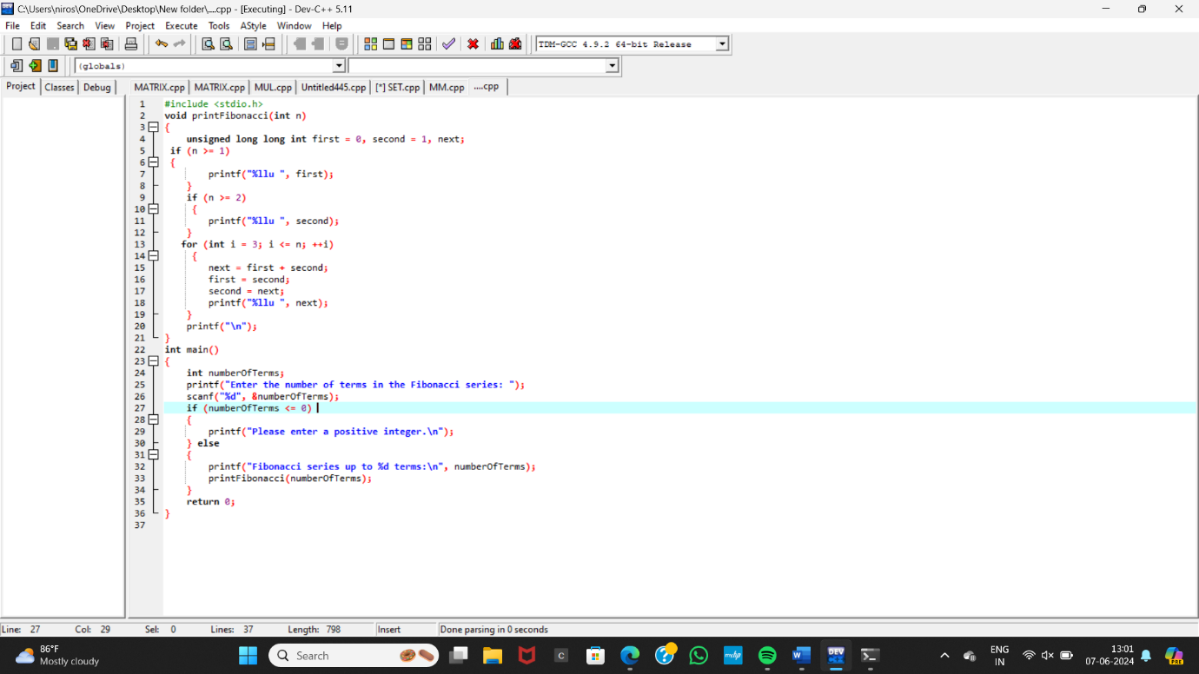

**OUTPUT:**

